**Materi HTML + CSS**

**“Studi kasus : Company profil SMK Triguna Utama Syarif Hidayatullah”**

**Hasil running kode program**

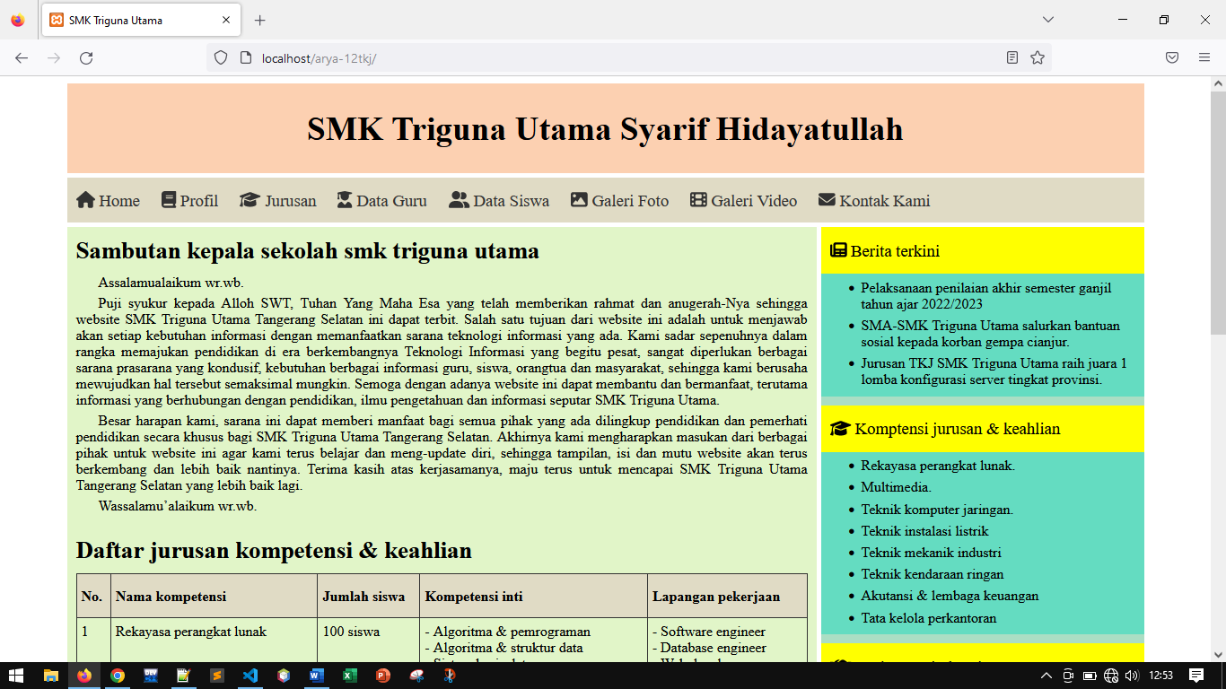

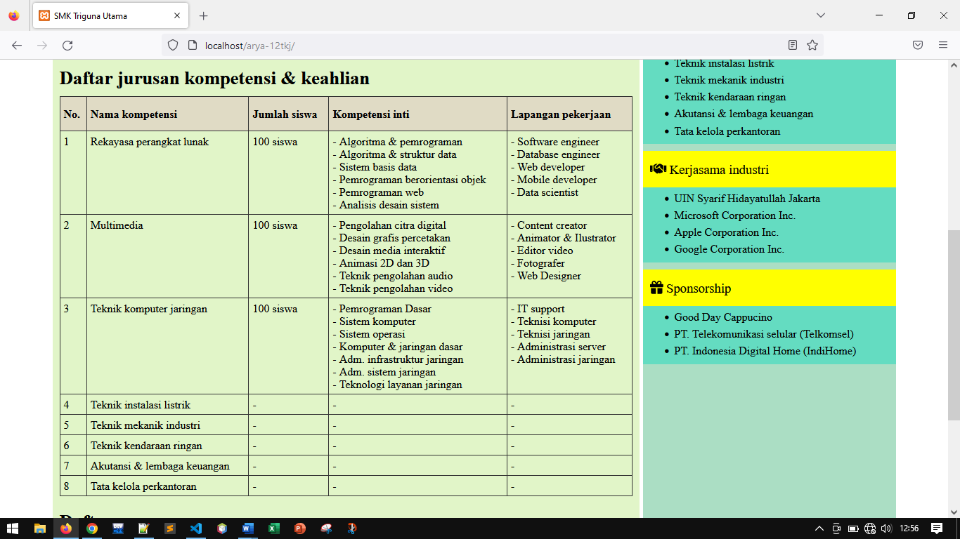

**Struktur path**

“C:\xampp\htdocs\nama-12tkj\”

**Struktur direktori**

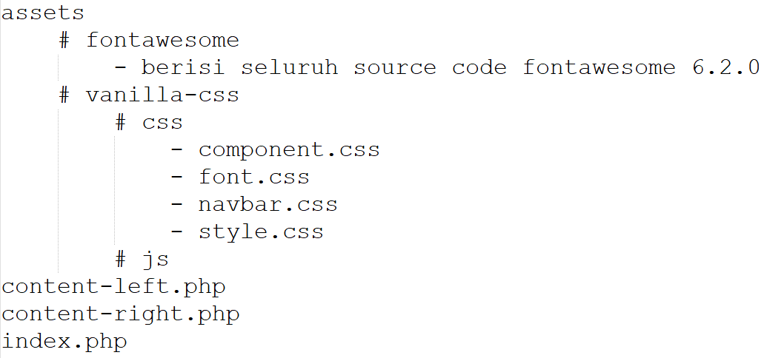

**File name “index.php”**

|  |
| --- |
| <!DOCTYPE html>  <html lang=**"en"**>  <head>  <!-- set title this website -->  <title>**SMK Triguna Utama**</title>  <!-- custom vanilla-css for template website -->  <link rel=**"stylesheet"** href=**"assets/vanilla-css/css/style.css"**>  <!-- custom vanilla-css for navbar -->  <link rel=**"stylesheet"** href=**"assets/vanilla-css/css/navbar.css"**>  <!-- custom vanilla-css for component website -->  <link rel=**"stylesheet"** href=**"assets/vanilla-css/css/component.css"**>  <!-- custom vanilla-css for font website -->  <link rel=**"stylesheet"** href=**"assets/vanilla-css/css/font.css"**>  <!-- custom fontawesome for icon-icon website -->  <link rel=**"stylesheet"** href=**"assets/fontawesome/css/fontawesome.css"**>  <link rel=**"stylesheet"** href=**"assets/fontawesome/css/brands.css"**>  <link rel=**"stylesheet"** href=**"assets/fontawesome/css/solid.css"**>  </head>  <body>  <!-- --------------------------------------------------- -->  <!-- /.wrapper ----------------------------------------- -->  <!-- --------------------------------------------------- -->  <div class=**"wrapper"** id=**"wrapper"**>  <!-- --------------------------------------------------- -->  <!-- /.header ------------------------------------------ -->  <!-- --------------------------------------------------- -->  <div class=**"header"** id=**"header"**>  <h1 class=**"h-header"**>**SMK Triguna Utama Syarif Hidayatullah**</h1>  </div>  <!-- ./header -->  <!-- --------------------------------------------------- -->  <!-- /.navbar ------------------------------------------ -->  <!-- --------------------------------------------------- -->  <div class=**"navbar"** id=**"navbar"**>  <nav>  <a class=**"a-nav"** href=**"#"**>  <i class=**"fa-solid fa-home"**></i> **Home**</a>  <a class=**"a-nav"** href=**"#"**>  <i class=**"fa-solid fa-book"**></i> **Profil**</a>  <a class=**"a-nav"** href=**"#"**>  <i class=**"fa-solid fa-graduation-cap"**></i> **Jurusan**</a>  <a class=**"a-nav"** href=**"#"**>  <i class=**"fa-solid fa-user-graduate"**></i> **Data Guru**</a>  <a class=**"a-nav"** href=**"#"**>  <i class=**"fa-solid fa-user-group"**></i> **Data Siswa**</a>  <a class=**"a-nav"** href=**"#"**>  <i class=**"fa-solid fa-image"**></i> **Galeri Foto**</a>  <a class=**"a-nav"** href=**"#"**>  <i class=**"fa-solid fa-film"**></i> **Galeri Video**</a>  <a class=**"a-nav"** href=**"#"**>  <i class=**"fa-solid fa-envelope"**></i> **Kontak Kami**</a>  </nav>  </div>  <!-- ./navbar -->  <!-- --------------------------------------------------- -->  <!-- /.content ----------------------------------------- -->  <!-- --------------------------------------------------- -->  <div class=**"content"** id=**"content"**>  <div class=**"content-left"** id=**"content-left"**>  <?php **include** "content-left.php"; ?>  </div>  <!-- ./content-left -->  <div class=**"content-right"** id=**"content-right"**>  <?php **include** "content-right.php"; ?>  </div>  <!-- ./content-right -->  </div>  <!-- ./content -->  <!-- --------------------------------------------------- -->  <!-- /.footer ------------------------------------------ -->  <!-- --------------------------------------------------- -->  <div class=**"footer"** id=**"footer"**>  <p>**Copyright 2022 all rights reserved by Aryajaya Alamsyah, S.Kom**</p>  </div>  <!-- ./footer -->  </div>  <!-- ./wrapper -->  <!-- custom JS fontawesome for icon-icon website -->  <script src=**"assets/fontawesome/js/fontawesome.js"**></script>  <script src=**"assets/fontawesome/js/brands.js"**></script>  <script src=**"assets/fontawesome/js/solid.js"**></script>  </body>  </html> |

**File name “content-left.php”**

|  |
| --- |
| <!-- --------------------------------------------------- -->  <!-- /.sambutan kepala sekolah ------------------------- -->  <!-- --------------------------------------------------- -->  <div class=**"article"**>  <div class=**"article-header"**>  <h1 class=**"h-sub-header"**>**Sambutan kepala sekolah smk triguna utama**</h1>  </div>  <!-- ./article-header -->  <div class=**"article-body"**>  <p class=**"p-article"**>**Assalamualaikum wr.wb.**</p>  <p class=**"p-article"**>  **Puji syukur kepada Alloh SWT, Tuhan Yang Maha Esa yang telah memberikan rahmat**  **dan anugerah-Nya sehingga website SMK Triguna Utama Tangerang Selatan ini dapat**  **terbit. Salah satu tujuan dari website ini adalah untuk menjawab akan setiap**  **kebutuhan informasi dengan memanfaatkan sarana teknologi informasi yang ada. Kami**  **sadar sepenuhnya dalam rangka memajukan pendidikan di era berkembangnya Teknologi**  **Informasi yang begitu pesat, sangat diperlukan berbagai sarana prasarana yang**  **kondusif, kebutuhan berbagai informasi guru, siswa, orangtua dan masyarakat,**  **sehingga kami berusaha mewujudkan hal tersebut semaksimal mungkin. Semoga dengan**  **adanya website ini dapat membantu dan bermanfaat, terutama informasi yang**  **berhubungan dengan pendidikan, ilmu pengetahuan dan informasi seputar SMK Triguna**  **Utama Syarif Hidayatullah.**</p>  <p class=**"p-article"**>  **Besar harapan kami, sarana ini dapat memberi manfaat bagi semua pihak yang ada**  **dilingkup pendidikan dan pemerhati pendidikan secara khusus bagi SMK Triguna**  **Utama Tangerang Selatan. Akhirnya kami mengharapkan masukan dari berbagai pihak**  **untuk website ini agar kami terus belajar dan meng-update diri, sehingga tampilan,**  **isi dan mutu website akan terus berkembang dan lebih baik nantinya. Terima kasih**  **atas kerjasamanya, maju terus untuk mencapai SMK Triguna Utama Tangerang Selatan**  **yang lebih baik lagi.**</p>  <p class=**"p-article"**>**Wassalamu’alaikum wr.wb.**</p>  </div>  <!-- ./article-body -->  </div>  <!-- ./article -->  <!-- --------------------------------------------------- -->  <!-- /.jurusan kompetensi & keahlian ------------------- -->  <!-- --------------------------------------------------- -->  <div class=**"article"**>  <div class=**"article-header"**>  <h1 class=**"h-sub-header"**>**Daftar jurusan kompetensi** & **keahlian**</h1>  </div>  <div class=**"article-body"**>  <table class=**"show-table"**>  <thead>  <tr>  <th>**No.**</th>  <th>**Nama kompetensi**</th>  <th>**Jumlah siswa**</th>  <th>**Kompetensi inti**</th>  <th>**Lapangan pekerjaan**</th>  </tr>  </thead>  <tbody>  <tr>  <td>**1**</td>  <td>**Rekayasa perangkat lunak**</td>  <td>**100 siswa**</td>  <td>  **- Algoritma** & **pemrograman** <br>  **- Algoritma** & **struktur data** <br>  **- Sistem basis data** <br>  **- Pemrograman berorientasi objek** <br>  **- Pemrograman web** <br>  **- Analisis desain sistem** <br>  </td>  <td>  **- Software engineer** <br>  **- Database engineer** <br>  **- Web developer** <br>  **- Mobile developer** <br>  **- Data scientist** <br>  </td>  </tr>  <tr>  <td>**2**</td>  <td>**Multimedia**</td>  <td>**100 siswa**</td>  <td>  **- Pengolahan citra digital** <br>  **- Desain grafis percetakan** <br>  **- Desain media interaktif** <br>  **- Animasi 2D dan 3D** <br>  **- Teknik pengolahan audio** <br>  **- Teknik pengolahan video** <br>  </td>  <td>  **- Content creator** <br>  **- Animator** & **Ilustrator** <br>  **- Editor video** <br>  **- Fotografer** <br>  **- Web Designer** <br>  </td>  </tr>  <tr>  <td>**3**</td>  <td>**Teknik komputer jaringan**</td>  <td>**100 siswa**</td>  <td>  **- Pemrograman Dasar** <br>  **- Sistem komputer** <br>  **- Sistem operasi** <br>  **- Komputer** & **jaringan dasar** <br>  **- Adm. infrastruktur jaringan** <br>  **- Adm. sistem jaringan** <br>  **- Teknologi layanan jaringan** <br>  </td>  <td>  **- IT support** <br>  **- Teknisi komputer** <br>  **- Teknisi jaringan** <br>  **- Administrasi server** <br>  **- Administrasi jaringan** <br>  </td>  </tr>  <tr>  <td>**4**</td>  <td>**Teknik instalasi listrik**</td>  <td>**-**</td>  <td>**-**</td>  <td>**-**</td>  </tr>  <tr>  <td>**5**</td>  <td>**Teknik mekanik industri**</td>  <td>**-**</td>  <td>**-**</td>  <td>**-**</td>  </tr>  <tr>  <td>**6**</td>  <td>**Teknik kendaraan ringan**</td>  <td>**-**</td>  <td>**-**</td>  <td>**-**</td>  </tr>  <tr>  <td>**7**</td>  <td>**Akutansi** & **lembaga keuangan**</td>  <td>**-**</td>  <td>**-**</td>  <td>**-**</td>  </tr>  <tr>  <td>**8**</td>  <td>**Tata kelola perkantoran**</td>  <td>**-**</td>  <td>**-**</td>  <td>**-**</td>  </tr>  </tbody>  </table>  </div>  <!-- ./article-body -->  </div>  <!-- ./article -->  <!-- --------------------------------------------------- -->  <!-- /.daftar nama guru-guru --------------------------- -->  <!-- --------------------------------------------------- -->  <div class=**"article"**>  <div class=**"article-header"**>  <h1 class=**"h-sub-header"**>**Daftar nama guru-guru** </h1>  </div>  <!-- ./article-header -->  <div class=**"article-body"**>  <table class=**"show-table"**>  <thead>  <tr>  <th>**No.**</th>  <th>**Nama Guru**</th>  <th>**Pendidikan**</th>  <th>**Universitas**</th>  <th>**Bid. Studi**</th>  </tr>  </thead>  <tbody>  <tr>  <td>**1**</td>  <td>**Aryajaya Alamsyah, S.Kom**</td>  <td>**S1**</td>  <td>**UIN Syarif Hidayatullah**</td>  <td>**Prod. tkj** & **mm**</td>  </tr>  <tr>  <td>**2**</td>  <td>**Dede Sumarna, ST**</td>  <td>**S1**</td>  <td>**Universitas Trisakti Jakarta**</td>  <td>**Prod. tkj** & **mm**</td>  </tr>  <tr>  <td>**3**</td>  <td>**Rully Setiawan, S.Kom**</td>  <td>**S1**</td>  <td>**Universitas Pamulang**</td>  <td>**Prod. tkj** & **mm**</td>  </tr>  <tr>  <td>**4**</td>  <td>**Andhika Nurambia, S.Kom.**</td>  <td>**S1**</td>  <td>**Universitas Indraprasta**</td>  <td>**Prod. tkj** & **mm**</td>  </tr>  </tbody>  </table>  </div>  <!-- ./article-body -->  </div>  <!-- ./article --> |

**File name “content-right.php”**

|  |
| --- |
| <!-- --------------------------------------------------- -->  <!-- /. berita terkini --------------------------------- -->  <!-- --------------------------------------------------- -->  <div class=**"box"**>  <div class=**"box-header"**>  <p class=**"p-sub-header"**><i class=**"fa-solid fa-newspaper"**></i> **Berita terkini**</p>  </div>  <div class=**"box-body"**>  <ul class=**"ul-li-box"**>  <li>**Pelaksanaan penilaian akhir semester ganjil tahun ajar 2022/2023**</li>  <li>**SMA-SMK Triguna Utama salurkan bantuan sosial kepada korban gempa bumi**  **di kabupaten cianjur.**</li>  <li>**Jurusan TKJ SMK Triguna Utama raih juara 1 lomba konfigurasi server tingkat**  **provinsi banten.**</li>  </ul>  </div>  </div>  <!-- /. berita terkini -->  <!-- --------------------------------------------------- -->  <!-- /.jurusan kompetensi & keahlian ------------------- -->  <!-- --------------------------------------------------- -->  <div class=**"box"**>  <div class=**"box-header"**>  <p class=**"p-sub-header"**><i class=**"fa-solid fa-graduation-cap"**></i>  **Komptensi jurusan** & **keahlian**</p>  </div>  <div class=**"box-body"**>  <ul class=**"ul-li-box"**>  <li>**Rekayasa perangkat lunak.**</li>  <li>**Multimedia.**</li>  <li>**Teknik komputer jaringan.**</li>  <li>**Teknik instalasi listrik**</li>  <li>**Teknik mekanik industri**</li>  <li>**Teknik kendaraan ringan**</li>  <li>**Akutansi** & **lembaga keuangan**</li>  <li>**Tata kelola perkantoran**</li>  </ul>  </div>  </div>  <!-- /. jurusan kompetensi & keahlian -->  <!-- --------------------------------------------------- -->  <!-- /.kerjasama industri ------------------------------ -->  <!-- --------------------------------------------------- -->  <div class=**"box"**>  <div class=**"box-header"**>  <p class=**"p-sub-header"**><i class=**"fa-solid fa-handshake"**></i> **Kerjasama industri**</p>  </div>  <div class=**"box-body"**>  <ul class=**"ul-li-box"**>  <li>**UIN Syarif Hidayatullah Jakarta**</li>  <li>**Microsoft Corporation Inc.**</li>  <li>**Apple Corporation Inc.**</li>  <li>**Google Corporation Inc.** </li>  </ul>  </div>  </div>  <!-- -/.kerjasama industri -->  <!-- --------------------------------------------------- -->  <!-- /.Sponsorship ------------------------------------- -->  <!-- --------------------------------------------------- -->  <div class=**"box"**>  <div class=**"box-header"**>  <p class=**"p-sub-header"**><i class=**"fa-solid fa-gift"**></i> **Sponsorship**</p>  </div>  <div class=**"box-body"**>  <ul class=**"ul-li-box"**>  <li>**Good Day Cappucino**</li>  <li>**PT. Telekomunikasi selular (Telkomsel)**</li>  <li>**PT. Indonesia Digital Home (IndiHome)**</li>  </ul>  </div>  </div>  <!-- /.Sponsorship --> |

**File name “style.css”**

|  |
| --- |
| /* ------------------------------------------------------ */  /* CSS for wrapper -------------------------------------- */  /* ------------------------------------------------------ */  **.**wrapper **{**  **border: 0px solid black;**  **width: 1200px;**  **height: auto;**  **margin: auto;**  **}**  /* ------------------------------------------------------ */  /* CSS for header --------------------------------------- */  /* ------------------------------------------------------ */  **.**header **{**  **background-color: #FCD0B1;**  **display: inline-flex;**  **justify-content: center;**  **align-items: center;**  **width: 1200px;**  **height: 100px;**  **margin: 0px 0px 5px 0px;**  **padding: 0px 0px 0px 0px;**  **}**  /* ------------------------------------------------------ */  /* CSS for navbar --------------------------------------- */  /* ------------------------------------------------------ */  **.**navbar **{**  **background-color: #E0DBC5;**  **display: inline-flex;**  **width: 1200px;**  **height: 50px;**  **margin: 0px 0px 5px 0px;**  **padding: 0px 0px 0px 0px;**  **}**  /* ------------------------------------------------------ */  /* CSS for content --------------------------------------- */  /* ------------------------------------------------------ */  **.**content**{**  **display: inline-flex;**  **width: 1200px;**  **height: auto;**  **}**  **.**content-left **{**  **background-color: #E1F5C8;**  **display: inline-block;**  **width: 835px;**  **height: auto;**  **margin: 0px 5px 5px 0px;**  **padding: 0px 0px 0px 0px;**  **}**  **.**content-right **{**  **background-color: #ABDEC4;**  **display: inline-block;**  **width: 360px;**  **height: auto;**  **margin: 0px 0px 5px 0px;**  **padding: 0px 0px 0px 0px;**  **}**  **.**footer **{**  **background-color: #FCD0B1;**  **display: inline-flex;**  **justify-content: center;**  **align-items: center;**  **width: 1200px;**  **height: 50px;**  **margin: 0px 0px 0px 0px;**  **padding: 0px 0px 0px 0px;**  **}** |

**File name “navbar.css”**

|  |
| --- |
| .navbar a {      color: #333;      display: inline-block;      width: auto;      height: auto;      margin: 0px 0px 0px 0px;      padding: 14px 10px 14px 10px;      text-decoration: none;  }  .navbar a:hover {      background-color: #c3b98e;  } |

**File name “font.css”**

|  |
| --- |
| **.**h-header**{**  **font-size: 28pt;**  **}**  **.**h-sub-header**{**  **font-size: 20pt;**  **text-indent: 0px;**  **text-align: justify;**  **margin: 0px 0px 0px 0px;**  **padding: 10px 0px 10px 0px;**  **}**  **.**a-nav **{**  **font-size: 14pt;**  **}**  **.**p-article **{**  **font-size: 12pt;**  **text-indent: 25px;**  **text-align: justify;**  **margin: 0px 0px 0px 0px;**  **padding: 0px 0px 5px 0px;**  **}**  **.**p-sub-header**{**  **font-size: 14pt;**  **margin: 0px 0px 0px 0px;**  **padding: 15px 0px 15px 0px;**  **}**  **.**ul-li-box**{**  **font-size: 12pt;**  **margin-top: 5px;**  **margin-bottom: 5px;**  **}**  **.**ul-li-box li**{**  **padding-top: 0px;**  **padding-bottom: 5px;**  **}** |

**File name “component.css”**

|  |
| --- |
| /* ------------------------------------------------------ */  /* CSS for article -------------------------------------- */  /* ------------------------------------------------------ */  **.**article **{**  **display: inline-block;**  **background-color: none;**  **width: inherit;**  **height: auto;**  **margin: 0px 0px 10px 0px;**  **padding: 0px 0px 0px 0px;**  **}**  **.**article-header **{**  **background-color: none;**  **width: auto;**  **height: auto;**  **margin: 0px 0px 0px 0px;**  **padding: 0px 10px 0px 10px;**  **}**  **.**article-body **{**  **background-color: none;**  **width: auto;**  **height: auto;**  **margin: 0px 0px 0px 0px;**  **padding: 0px 10px 0px 10px;**  **}**  /* ------------------------------------------------------ */  /* CSS for box ------------------------------------------ */  /* ------------------------------------------------------ */  **.**box **{**  **display: inline-block;**  **background-color: #64dcc1;**  **width: inherit;**  **height: auto;**  **margin: 0px 0px 10px 0px;**  **padding: 0px 0px 0px 0px;**  **}**  **.**box-header **{**  **background-color: yellow;**  **width: auto;**  **height: auto;**  **margin: 0px 0px 0px 0px;**  **padding: 0px 10px 0px 10px;**  **}**  **.**box-body **{**  **background-color: none;**  **width: auto;**  **height: auto;**  **margin: 0px 0px 0px 0px;**  **padding: 0px 5px 0px 5px;**  **}**  /* ------------------------------------------------------ */  /* CSS for table ---------------------------------------- */  /* ------------------------------------------------------ */  **.**show-table**{**  **width: 815px;**  **}**  **.**show-table**,** th**,** td **{**  **border: 1px solid #333;**  **border-collapse: collapse;**  **}**  th**{**  **background-color: #E0DBC5;**  **text-align: left;**  **vertical-align: baseline;**  **margin: 0px 0px 0px 0px;**  **padding: 15px 5px 15px 5px;**  **}**  td**{**  **background-color: none;**  **text-align: left;**  **vertical-align: baseline;**  **margin: 0px 0px 0px 0px;**  **padding: 5px 5px 5px 5px;**  **}** |